Module 2: Personalize Customer Experience AI in CI and Customer Add-In

Hands-on Lab Step-by-Step

September 2021

Contents

Activate Digital Sales B2B Scenario 1

Lab Prerequisites 1

Scenario: ContoTech Worldwide Enterprise Retail Company 2

Goals for this lab 3

Exercise 1: Predict Data with the Help of AI 3

Exercise 2: Product Recommendations (Preview) 3

Exercise 3: Manage Segments from Predictions 3

Exercise 4: Export Generated Segment to Dynamics 365 Marketing 3

Exercise 5: Install Customer Card Add-in (Preview) 3

Task 1: Install the Customer Card Add-in (Preview) 4

Task 2: Configure the Customer Card Add-in 5

Add Customer Card controls to forms 7

Upgrade Customer Card Add-in 8

Copyright 9

# Activate Digital Sales B2B Scenario

## Lab Prerequisites

Follow the pre-requisite steps that are included in the lab package. Before beginning this lab, confirm that you have provisioned a Dynamics 365 environment where you will save your apps, data, and other customizations with license to access Sales, Marketing, Customer Service with OmniChannels, Power Platform, Customer Insight, Teams, and Customer Voice.

Basic knowledge and familiar with:

1. Dynamics 365 Customer Engagement Fundamentals, Sales, Marketing, Services
2. Dynamics 365 Customer Insight
3. Power Platform

**Linkedin Sales Navigator Pre-requisites:**

Review the following prerequisites to install and enable LinkedIn Sales Navigator:

* You have a System Administrator security role in Dynamics 365.
* You can integrate LinkedIn Sales Navigator with Dynamics 365 Customer Engagement only and can't be integrated with a Microsoft Dataverse organization.
* You have a [Microsoft Relationship Sales subscription](https://dynamics.microsoft.com/sales/relationship-sales/) for Dynamics 365. Microsoft Relationship Sales (MRS) solution includes Dynamics Sales Enterprise and [LinkedIn Sales Navigator Team](https://business.linkedin.com/sales-solutions/sales-navigator-customer-hub/resources/crm) license.  
  or  
  If you don't have MRS Solution or MRS Solution plus for LinkedIn Sales Navigator license, you'll need to sign up your team for [LinkedIn Sales Navigator Team](https://business.linkedin.com/sales-solutions/sales-navigator-customer-hub/resources/crm) or [LinkedIn Sales Navigator Enterprise](https://business.linkedin.com/sales-solutions/sales-navigator-customer-hub/resources/crm).

*We recommend having a Microsoft Relationship Sales solution Plus license that includes Dynamics 365 Sales Enterprise and **[LinkedIn Sales Navigator Enterprise](https://business.linkedin.com/sales-solutions/sales-navigator-customer-hub/resources/crm)** license. To learn more, see the **Dynamics 365 Sales** section from the **[Microsoft Dynamics 365 Licensing Guide](https://go.microsoft.com/fwlink/?LinkId=866544)**.

* You'll need to enable JavaScript in your browser.
* You'll need to disable your pop-up blocker for the Dynamics 365 domain.

## Scenario: ContoTech Worldwide Enterprise Retail Company

Welcome to the ContoTech, No #1 in Technology! We specialize in all the IT enthusiasts’ needs; we offer variety of high-quality products from different reliable partners around the world, we operate more than 70 stores worldwide, during this pandemic we are committed to be the pioneer of digitally transformed IT retail company that is not only selling in traditional ways but also innovative ways to reach everyone everywhere with affordable high quality products with personalized experience for everyone.

Now, we have you as our newest IT consultant team member, we have no doubt that we will achieve our goals with you. As we continue to grow, there are multiple tasks are assigned to you to tackle our problems.

1. Multiple stores operate differently, and we have online stores, multiple social media connections, all of them will have different data produced by their own system/platform.
2. During the pandemic, we are focusing more to the online sales with personalized customer experience, we want to ensure we understand and have personal connection with our customers, we want to have centralized data that in the end we can have 360-degree customer view and understand their behaviors and recommend better, alternative, or new products, plus make some predictions.
3. After we get full view of our customers, we will then be able to accurately target and incorporate them into our customer journey with the right segmentation to keep them updated with our marketing activities and upcoming products or deals. Social media is one of our best lead generations so far.
4. We also have our B2B customers that we want to build relationship to secure deal with them
5. We are company with growth mindset, we open feedback anytime from anyone through multiple channels, we often communicate with our customers via social media, we believe that it will improve our services and quality and build our brand effectively, we want to have active Facebook page with dedicated customer service line that will monitor the cases closely and take necessary action to keep customers happy without feeling of being ignored.
6. We understand there are issues faced by our customers, we want to quickly take action and review the cases and dispatch our right available engineers to solve the issues effectively. We have variety of products we need to have system that can dispatch the right engineers.
7. We want to have dashboard with insight that will monitor and assist our talented customer service team, so we will understand their workload and we can reduce their workload by implementing automated and robotic seamlessly customer experience for frequently asked queries and occurred incidents.

Post sales services are very important to retain customers in this increasing competition, after every case is being closed, we want to improve our quality, so we openly receive feedback from the customers to hear their voices about our services / products.

1. While we love to have system with standard features that can meet our requirements, we open to any configuration and customization that can improve our team productivity, we want to have product visualization when our sales creating new opportunities or generating quotes for our customers.

In today exercise, we need you to focus on requirement #1, this will need you to focus on unifying customers data to give better insight to serve better your customers and generate more leads.

## Goals for this lab

|  |  |  |  |
| --- | --- | --- | --- |
|  | After this lab you will be able to:   * Explore product recommendation and prediction using AI capabilities in Dynamics CI * Get a 360-degree view of your customers directly in Dynamics 365 apps * Know your customer in more personalized way |  | The time to complete this lab is [90] minutes. |

## Exercise 1: Predict Data with the Help of AI

*To be added

## Exercise 2: Product Recommendations (Preview)

*To be added

## Exercise 3: Manage Segments from Predictions

*To be added

## Exercise 4: Export Generated Segment to Dynamics 365 Marketing

*To be added

## Exercise 5: Install Customer Card Add-in (Preview)

With the Customer Card Add-in installed in a supported Dynamics 365 app you can choose to display demographics, insights, and activity timelines. The add-in will retrieve data from Customer Insights without affecting the data in the connected Dynamics 365 app.

**Prerequisites**

* The add-in only works with Dynamics 365 model-driven apps, such as Sales or Customer Service, version 9.0 and later.
* For your Dynamics 365 data to map to the audience insights customer profiles they need to be [ingested from the Dynamics 365 app using the Microsoft Dataverse connector](https://docs.microsoft.com/en-us/dynamics365/customer-insights/audience-insights/connect-power-query).
* All Dynamics 365 users of the Customer Card Add-in must be [added as users](https://docs.microsoft.com/en-us/dynamics365/customer-insights/audience-insights/permissions) in audience insights to see the data.
* [Configured search and filter capabilities](https://docs.microsoft.com/en-us/dynamics365/customer-insights/audience-insights/search-filter-index) in audience insights are required for lookup of data to work.
* Each add-in control relies on specific data in audience insights:
  + Measure control: Requires [configured measures](https://docs.microsoft.com/en-us/dynamics365/customer-insights/audience-insights/measures).
  + Intelligence control: Requires data generated using [predictions](https://docs.microsoft.com/en-us/dynamics365/customer-insights/audience-insights/predictions) or [custom models](https://docs.microsoft.com/en-us/dynamics365/customer-insights/audience-insights/custom-models).
  + Demographic control: Demographic fields(such as age or gender) are available in the unified customer profile.
  + Enrichment control: Requires active [enrichments](https://docs.microsoft.com/en-us/dynamics365/customer-insights/audience-insights/enrichment-hub) applied to customer profiles.
  + Timeline control: Requires [configured activities](https://docs.microsoft.com/en-us/dynamics365/customer-insights/audience-insights/activities).

#### Task 1: Install the Customer Card Add-in (Preview)

The Customer Card Add-in is a solution for customer engagement apps in Dynamics 365.

1. To install the solution, go to AppSource and search for **Dynamics Customer Card**. Select the [Customer Card Add-in on AppSource](https://appsource.microsoft.com/product/dynamics-365/mscrm.dynamics_365_customer_insights_customer_card_addin?tab=Overview) and select **Get It Now**.

1. You may need to sign in with your admin credentials for the Dynamics 365 app to install the solution. It can take some time for the solution to be installed to your environment. Now, install it to your own environment.











1. You will be directed to the Dynamics 365 apps in Power Platform Admin and you can see the solution is being installed.

1. You can wait and refresh to see the updated status

Then the status will be Installed



#### Task 2: Configure the Customer Card Add-in

1. As an admin, go to the **Advanced** **Settings** section in Dynamics 365 and select **Solutions**.

1. Select the **Display Name** link for the **Dynamics 365 Customer Insights Customer Card Add-in (Preview)** solution.

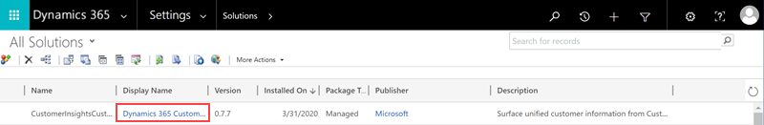

1. Select **Sign in** and enter the credentials for the admin account you use to configure Customer Insights.

**Note:**

Check that the browser pop-up blocker does not block the authentication window when you select the **Sign in** button.

1. Select the Customer Insights environment you want to fetch data from.
2. Define the field mapping to records in the Dynamics 365 app. Depending on your data in Customer Insights you can choose to map the following options:
   * To map with a contact, select the field in the Customer entity that matches the ID of your contact entity.
   * To map with an account, select the field in the Customer entity that matches the ID of your account entity.

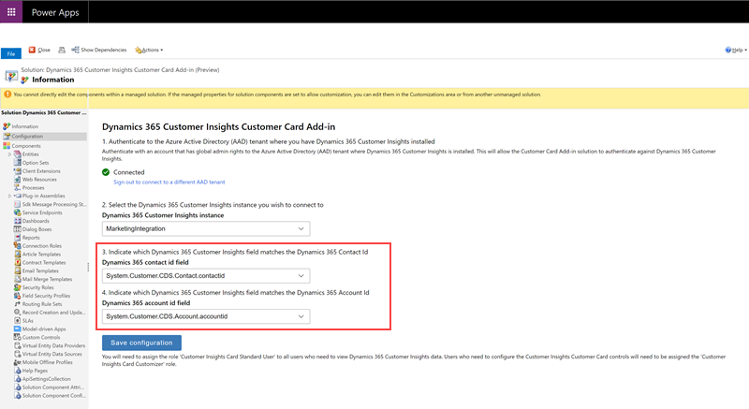

1. Select **Save configuration** to save the settings.
2. Next, you need to assign security roles in Dynamics 365 so users can customize and see the customer card. In Dynamics 365, go to **Settings** > **Security** > **Users**. Select the users to edit user roles and select **Manage roles**.
3. Assign the **Customer Insights Card Customizer** role to users who will customize the content shown on the card for the whole organization.

## Add Customer Card controls to forms

1. To add the Customer Card controls to your Contact form, go to the **Settings** > **Customizations** in Dynamics 365.
2. Select **Customize the System**.
3. Browse to the **Contact** entity, expand it and select **Forms**.
4. Select the contact form to which you want to add the Customer Card controls.

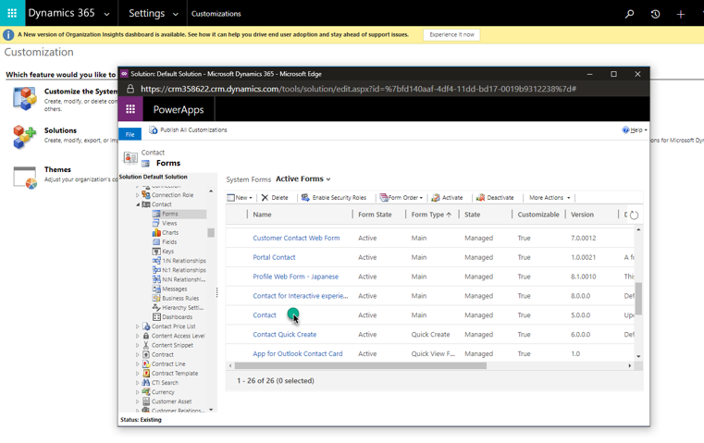

1. To add a control, in the form editor, drag any field from the **Field Explorer** to where you want the control to appear.
2. Select the field on the form that you just added, and select **Change Properties**.
3. Go to the **Controls** tab and select **Add Control**. Choose one of the available custom controls and select **Add**.
4. In the **Field Properties** dialog, clear the **Display label on the form** check box.
5. Select the **Web** option for the control. For the Enrichment control, select which enrichment type you want to display by configuring the **enrichmentType** field. Add a separate enrichment control for each enrichment type.
6. Select **Save** and **Publish** to publish the updated contact form.
7. Go to the published contact form. You'll see the newly added control. You might need to sign in the first time you use it.
8. To customize what you want to show on the custom control, select the edit button in the upper-right corner.

## Upgrade Customer Card Add-in

The Customer Card Add-in doesn't upgrade automatically. To upgrade to the latest version, follow this procedure in the Dynamics 365 app that has the Add-in installed.

1. In the Dynamics 365 app, go to **Settings** > **Customization** and select **Solutions**.
2. In the table of add-ins look for **CustomerInsightsCustomerCard** and select the row.
3. Select the **Apply Solution Upgrade** in the action bar.

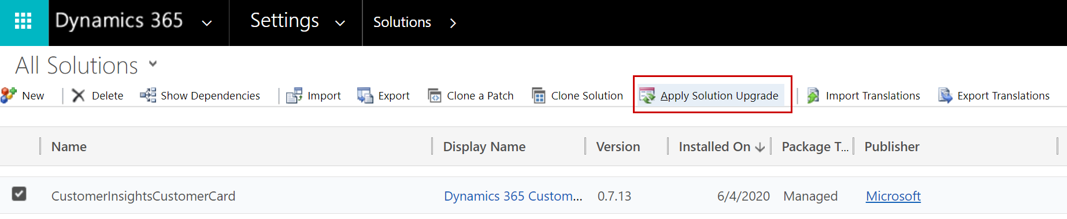

1. After starting the upgrade process, you'll see a loading indicator until the upgrade completes. If there's no newer version, the upgrade will show an error message.

# Copyright

© 2021 Microsoft Corporation. All rights reserved.

By using this demo/lab, you agree to the following terms:

The technology/functionality described in this demo/lab is provided by Microsoft Corporation for purposes of obtaining your feedback and to provide you with a learning experience. You may only use the demo/lab to evaluate such technology features and functionality and provide feedback to Microsoft. You may not use it for any other purpose. You may not modify, copy, distribute, transmit, display, perform, reproduce, publish, license, create derivative works from, transfer, or sell this demo/lab or any portion thereof.

COPYING OR REPRODUCTION OF THE DEMO/LAB (OR ANY PORTION OF IT) TO ANY OTHER SERVER OR LOCATION FOR FURTHER REPRODUCTION OR REDISTRIBUTION IS EXPRESSLY PROHIBITED.

THIS DEMO/LAB PROVIDES CERTAIN SOFTWARE TECHNOLOGY/PRODUCT FEATURES AND FUNCTIONALITY, INCLUDING POTENTIAL NEW FEATURES AND CONCEPTS, IN A SIMULATED ENVIRONMENT WITHOUT COMPLEX SET-UP OR INSTALLATION FOR THE PURPOSE DESCRIBED ABOVE. THE TECHNOLOGY/CONCEPTS REPRESENTED IN THIS DEMO/LAB MAY NOT REPRESENT FULL FEATURE FUNCTIONALITY AND MAY NOT WORK THE WAY A FINAL VERSION MAY WORK. WE ALSO MAY NOT RELEASE A FINAL VERSION OF SUCH FEATURES OR CONCEPTS. YOUR EXPERIENCE WITH USING SUCH FEATURES AND FUNCTIONALITY IN A PHYSICAL ENVIRONMENT MAY ALSO BE DIFFERENT.

**FEEDBACK**. If you give feedback about the technology features, functionality and/or concepts described in this demo/lab to Microsoft, you give to Microsoft, without charge, the right to use, share and commercialize your feedback in any way and for any purpose. You also give to third parties, without charge, any patent rights needed for their products, technologies and services to use or interface with any specific parts of a Microsoft software or service that includes the feedback. You will not give feedback that is subject to a license that requires Microsoft to license its software or documentation to third parties because we include your feedback in them. These rights survive this agreement.

MICROSOFT CORPORATION HEREBY DISCLAIMS ALL WARRANTIES AND CONDITIONS WITH REGARD TO THE DEMO/LAB, INCLUDING ALL WARRANTIES AND CONDITIONS OF MERCHANTABILITY, WHETHER EXPRESS, IMPLIED OR STATUTORY, FITNESS FOR A PARTICULAR PURPOSE, TITLE AND NON-INFRINGEMENT. MICROSOFT DOES NOT MAKE ANY ASSURANCES OR REPRESENTATIONS WITH REGARD TO THE ACCURACY OF THE RESULTS, OUTPUT THAT DERIVES FROM USE OF DEMO/ LAB, OR SUITABILITY OF THE INFORMATION CONTAINED IN THE DEMO/LAB FOR ANY PURPOSE.

**DISCLAIMER**

This demo/lab contains only a portion of new features and enhancements in Microsoft Power Apps. Some of the features might change in future releases of the product. In this demo/lab, you will learn about some, but not all, new features.